Creation of SQL Database:

Select SQL Database

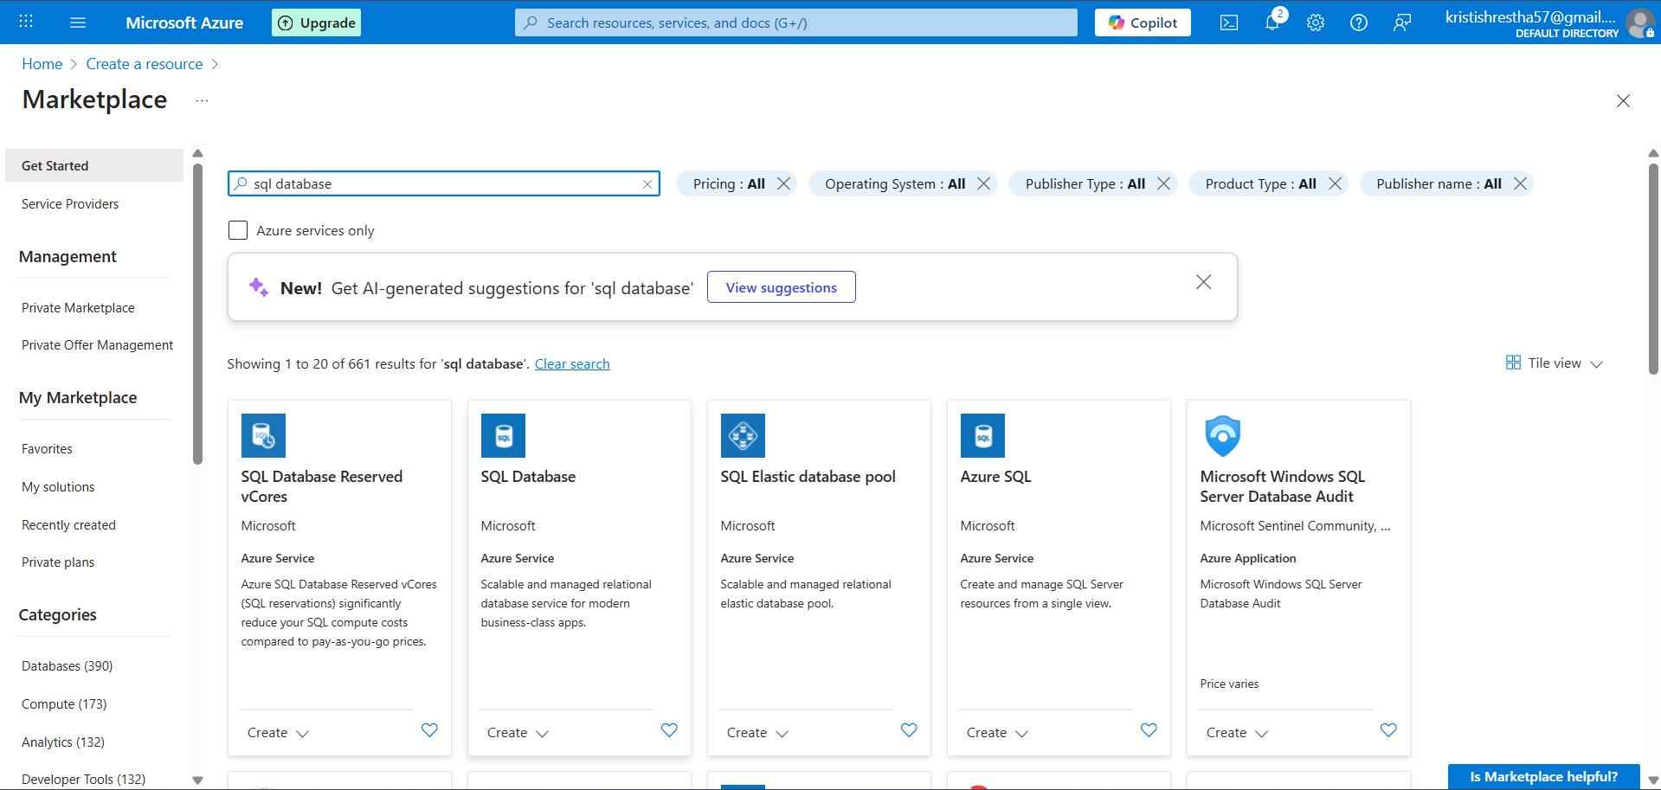

Click Create

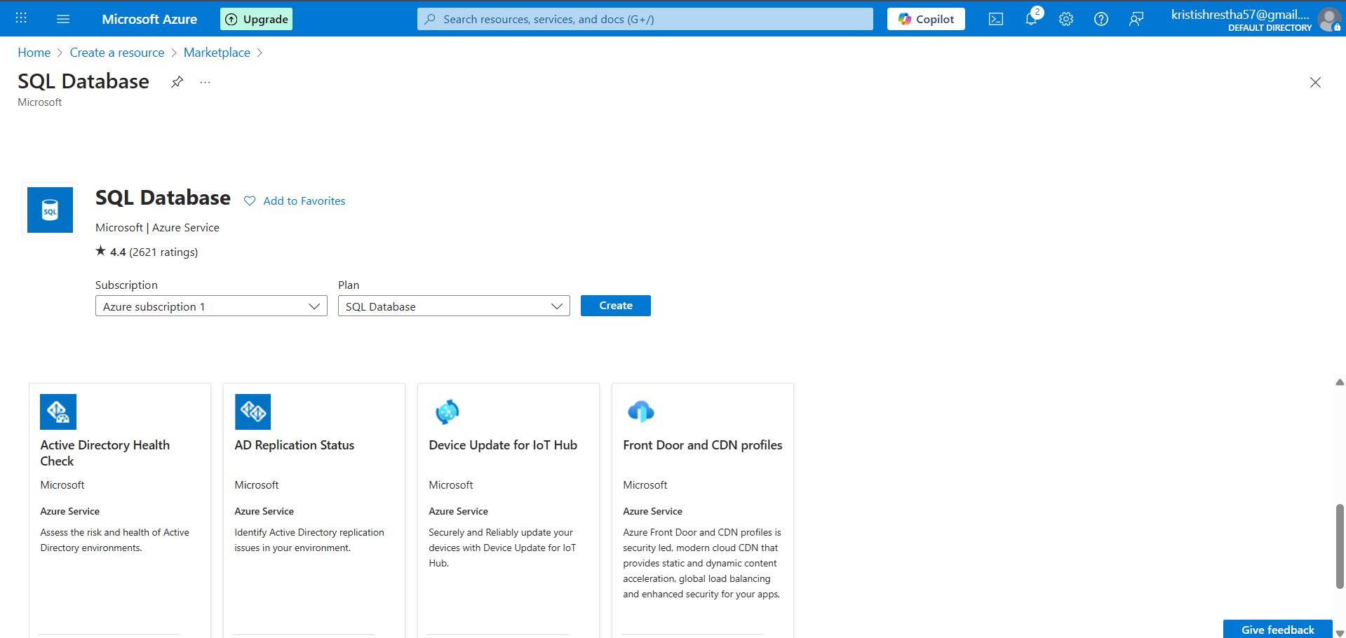

Click on create new resource group – az900-sql

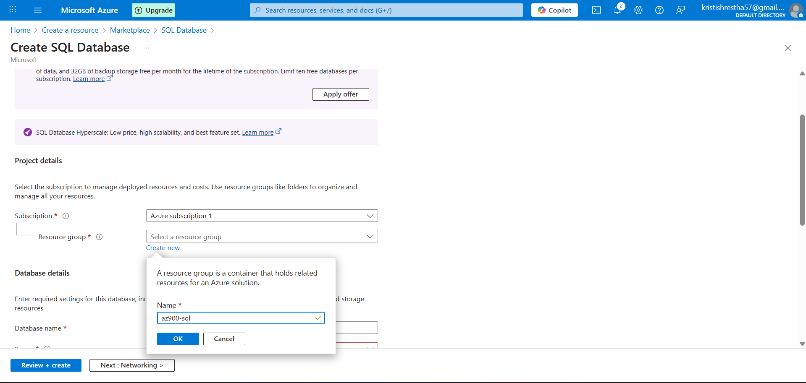

Now create database name -> kritirishikadb and then click on create new server

Type the new sql server name -> kritirishikasqlserver and at the bottom it should showcase as .database.windows.net

In authentication method select the Use SQL authentication option to get the password panel, after creating server admin login and password then click ok.

In the configure panel select standard budget friendly as service tier and click apply.

In this panel just click review + create

Click create

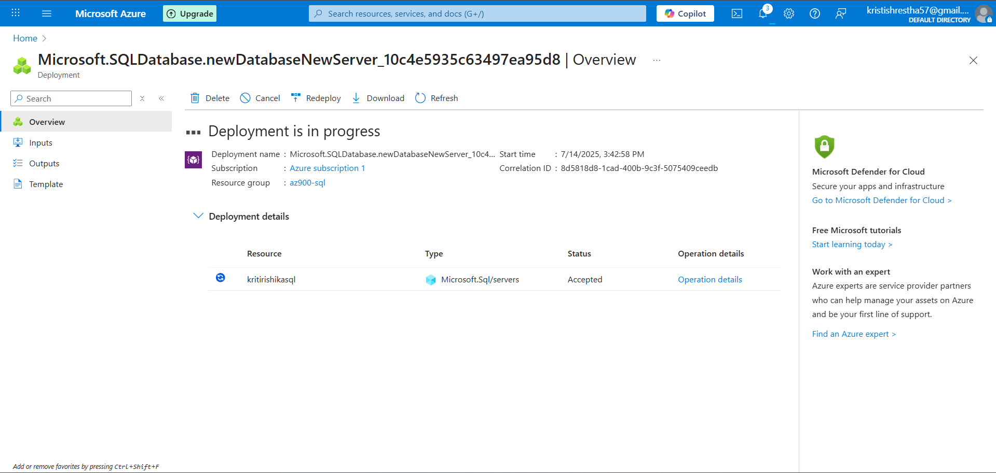

After deployment is completed click on go to resources.

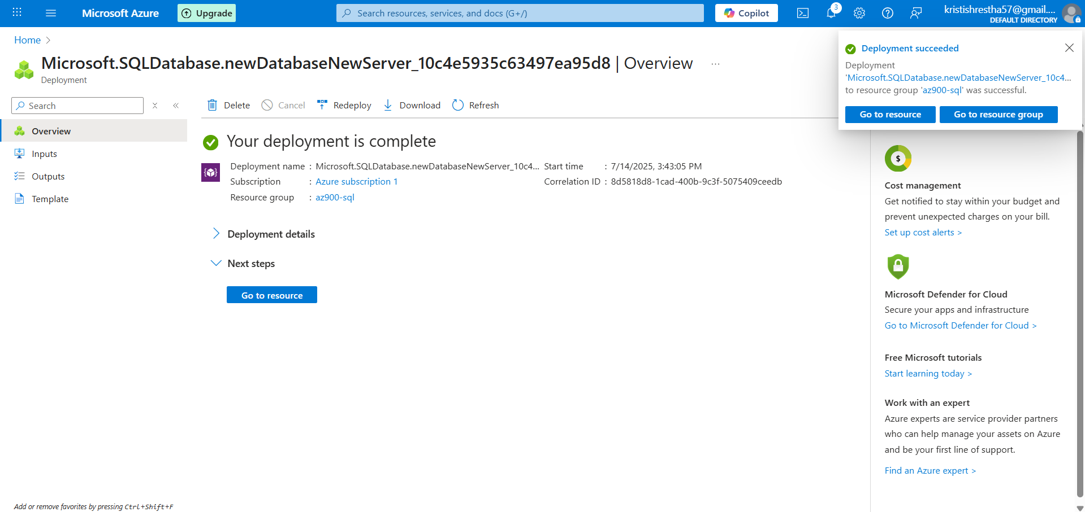

Here click query editor (preview) to login into the sql db.

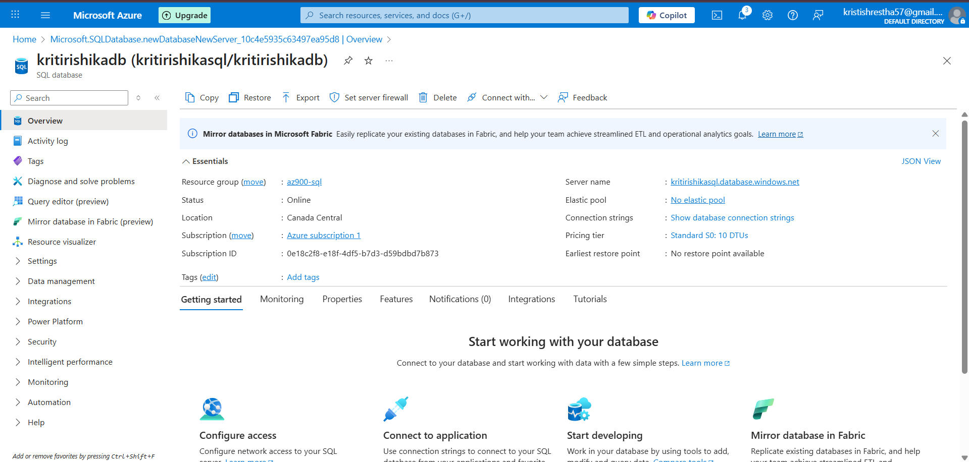

Type your password and click ok

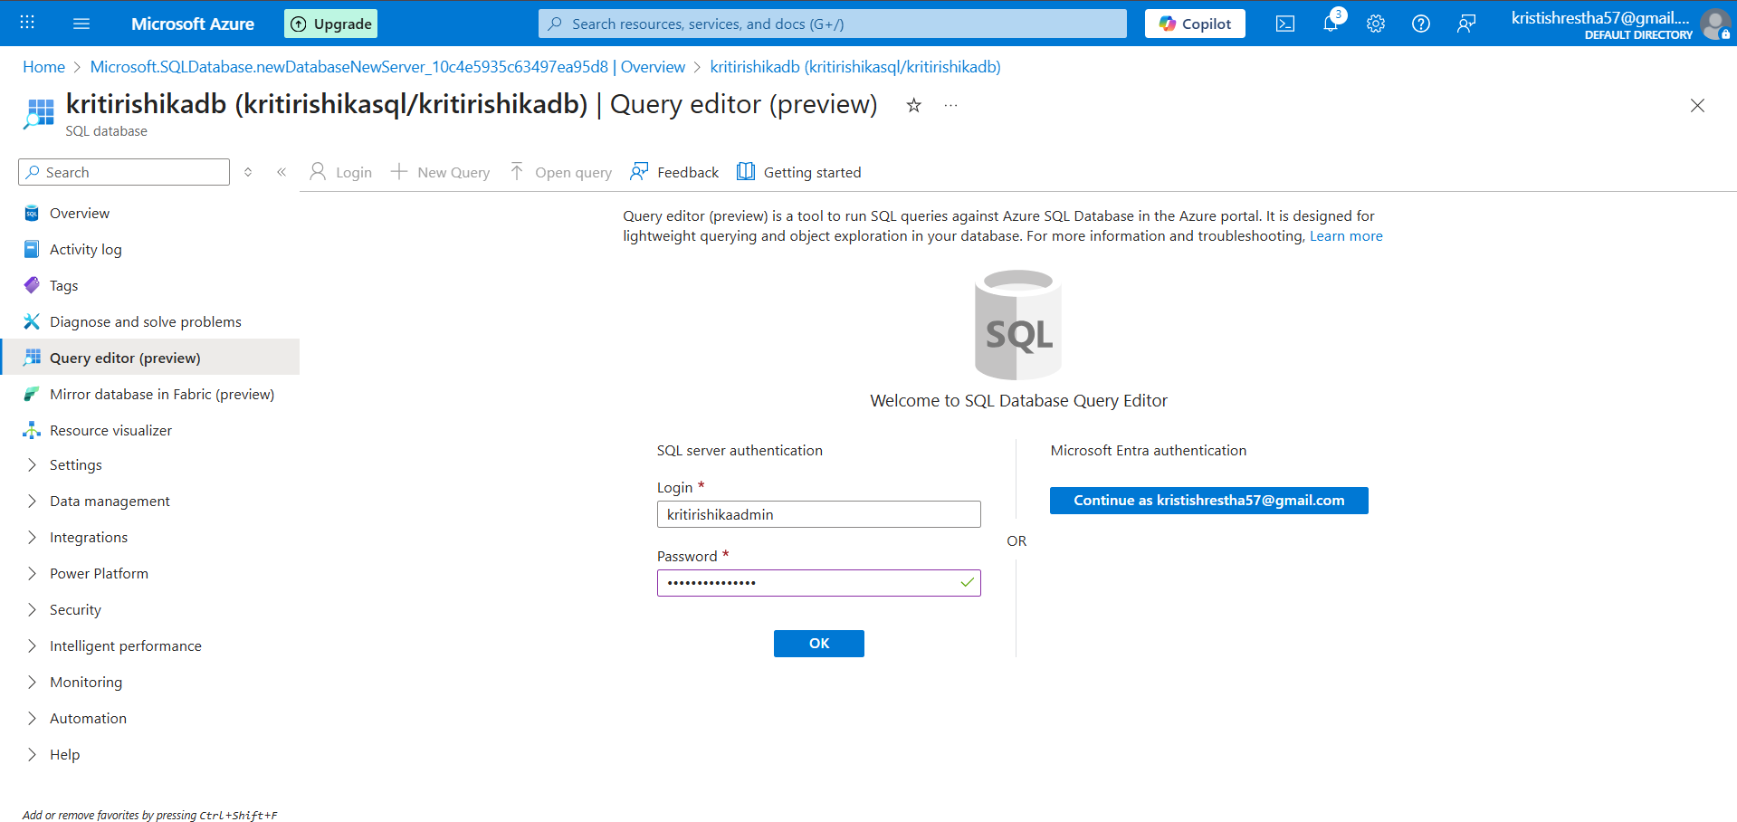

Create Table of movies

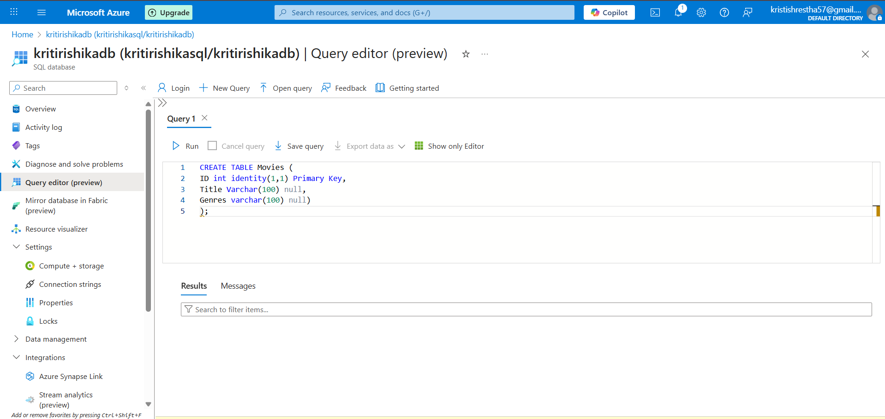

Click run to excute the query

Insert movies into the Movies database

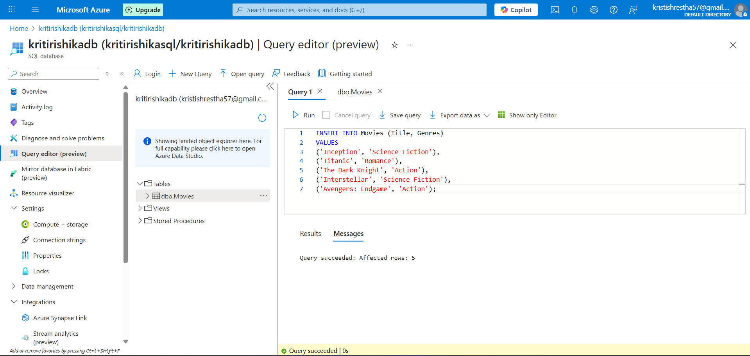

Create another table for Students and run the query

Insert data of students into the student’s database

To check if the query type select \* from students and then click run to see if the query was successful.

